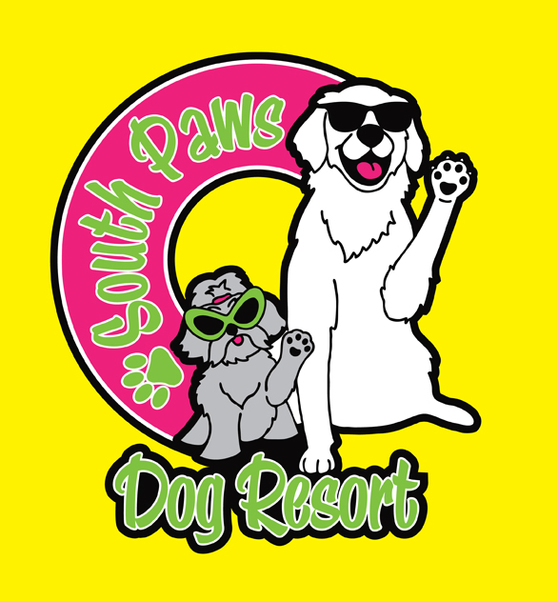

To My Veterinarian:

Please release any and all information concerning vaccinations, flea or parasite control and treatment to South Paws Dog Resort, LLC.
.
Thank You.

Signature: ______________________________________

Printed Name:___________________________________

Dogs’ Name:____________________________________

Date: __________________

